1.
#include<iostream>

using namespace std;

void bubblesort(int arr[], int size){
for(int i = 0; i < size - 1; i++){
bool swapped = false;

for(int j = 0; j < size - i - 1; j++){
if(arr[j] > arr[j+1]){
int temp = arr[j];
arr[j] = arr[j+1];
arr[j+1] = temp;
swapped = true;
}
}
if(!swapped){
break;
}
}
}

void printArray(int arr[], int size) {
for (int i = 0; i < size; i++) {
cout << arr[i] << " ";
}
cout << endl;
}

int main()
{
int arr[10];

cout << "Enter 10 integers:\n";
for (int i = 0; i < 10; i++) {
cin >> arr[i];
}

cout << "Array before sorting:\n";
printArray(arr, 10);

bubblesort(arr, 10);

cout << "Array after sorting:\n";
printArray(arr, 10);

return 0;
}
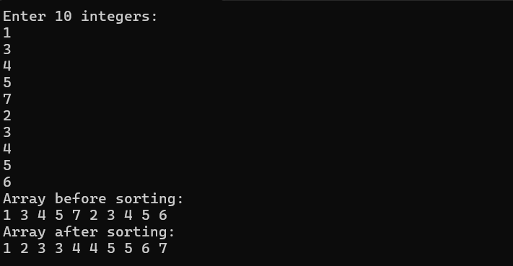2.
#include <iostream>
#include <string>

using namespace std;

void selectionSort(int arr[], int size, int &swapCount) {
for (int i = 0; i < size - 1; i++) {
int minIndex = i;

for (int j = i + 1; j < size; j++) {
if (arr[j] < arr[minIndex]) {
minIndex = j;
}
}

if (minIndex != i) {
swap(arr[i], arr[minIndex]);
swapCount++;
}
}
}

int main() {
int numbers[] = {5, 2, 8, 1, 9, 4, 6, 7, 3, 0};
int swapCount = 0;
int size = sizeof(numbers) / sizeof(numbers[0]);

selectionSort(numbers, size, swapCount);

cout << "Numbers sorted:\n";
for (int i = 0; i < size; i++) {
cout << numbers[i] << endl;
}
cout << "Number of swaps performed: " << swapCount << endl;
return 0;
}
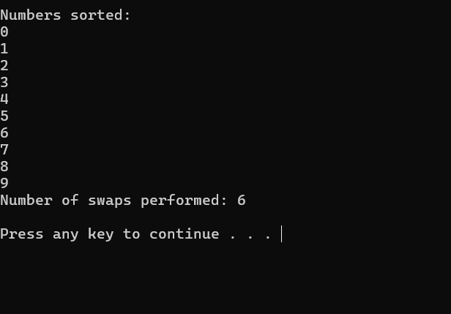
3.
#include<iostream>

using namespace std;

void insertionsort(int arr[], int n){
for(int i = 1; i < n; i++){
int key = arr[i];
int j = i - 1;
while(j >= 0 && arr[j] > key){
arr[j + 1] = arr[j];
j--;
}
arr[j + 1] = key;
}
}
void printArray(int arr[], int size) {
for (int i = 0; i < size; i++) {
cout << arr[i] << " ";
}
cout << endl;
}
int main()
{

int marks[] = {59, 44, 63, 78, 70, 68};

cout << "Array before sorting:\n";
printArray(marks, 6);
cout << "After sorting:\n";

insertionsort(marks, 6);
printArray(marks, 6);

return 0;
}
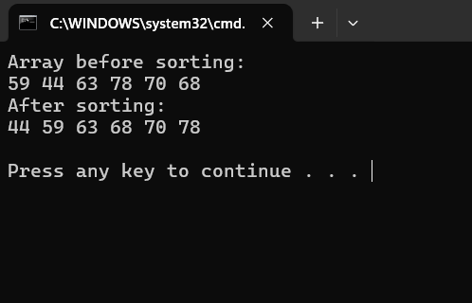
4
#include<iostream>
#include<string>
#include <cstdlib>
#include <ctime>
#include <utility> // for std::swap

using namespace std;

// Corrected Shell Sort implementation
void shellsort(int arr[], int n, int &swapcount) {
swapcount = 0; // Reset swap count for each call
int gap_seq[] = {10, 5, 2, 1}; // A more effective gap sequence

cout << "Gap sequence: ";
for (int gap : gap_seq) {
cout << gap << " ";
}
cout << endl;

for (int gap : gap_seq) {
for (int i = gap; i < n; i++) {
int temp = arr[i];
int j = i;
while (j >= gap && arr[j - gap] > temp) {
arr[j] = arr[j - gap];
swapcount++; // This is technically a shift
j -= gap;
}
arr[j] = temp;
}
}
}

// Corrected Insertion Sort
void insertionsort(int arr[], int n, int &shiftcount) {
shiftcount = 0; // Reset shift count for each call
for (int i = 1; i < n; i++) {
int key = arr[i];
int j = i - 1;
while (j >= 0 && arr[j] > key) {
arr[j + 1] = arr[j];
j--;
shiftcount++;
}
arr[j + 1] = key;
}
}

void printArray(int arr[], int size) {
for (int i = 0; i < size; i++) {
cout << arr[i] << " ";
}
cout << endl;
}

int main() {
srand(static_cast<unsigned int>(time(0)));
int arr[20];
int swapCount = 0;

for (int i = 0; i < 20; i++) {
arr[i] = rand() % 100 + 1;
}

cout << "Original array:\n";
printArray(arr, 20);
cout << endl;

int arr_copy_shell[20];
for(int i = 0; i < 20; i++) {
arr_copy_shell[i] = arr[i];
}
shellsort(arr_copy_shell, 20, swapCount);
cout << "Array after shell sort:" << endl;
printArray(arr_copy_shell, 20);
cout << "Shifts/Swaps in Shell Sort: " << swapCount << endl;

cout << "------------------------------------------\n";

int arr_copy_insertion[20];
for(int i = 0; i < 20; i++) {
arr_copy_insertion[i] = arr[i];
}
int shiftCount = 0;
insertionsort(arr_copy_insertion, 20, shiftCount);
cout << "Array after insertion sort:" << endl;
printArray(arr_copy_insertion, 20);
cout << "Shifts in Insertion Sort: " << shiftCount << endl;

cout << "------------------------------------------\n";

if (swapCount < shiftCount)
cout << "Shell Sort is faster (fewer shifts) on this dataset.\n";
else if (swapCount > shiftCount)
cout << "Insertion Sort is faster (fewer shifts) on this dataset.\n";
else
cout << "Both sorts performed similarly in terms of shifts.\n";

return 0;
}

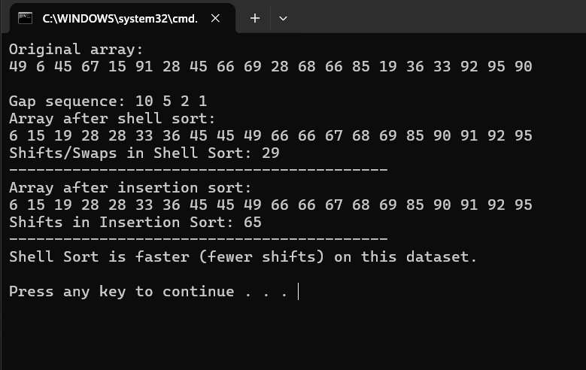
5.
#include <iostream>
#include <utility>

using namespace std;

void combSort(int arr[], int size, int &swapCount) {
swapCount = 0;
int gap = size;
float shrink = 1.3;
bool swapped = true;

while (gap > 1 || swapped) {
gap = static_cast<int>(gap / shrink);
if (gap < 1) {
gap = 1;
}

swapped = false;
cout << "Current gap: " << gap << endl;

for (int i = 0; i < size - gap; i++) {
if (arr[i] > arr[i + gap]) {
swap(arr[i], arr[i + gap]);
swapped = true;
swapCount++;
}
}
}
}

void bubbleSort(int arr[], int size, int &swapCount) {
swapCount = 0;
for (int i = 0; i < size - 1; i++) {
for (int j = 0; j < size - i - 1; j++) {
if (arr[j] > arr[j + 1]) {
swap(arr[j], arr[j + 1]);
swapCount++;
}
}
}
}

void printArray(const int arr[], int size) {
for (int i = 0; i < size; i++) {
cout << arr[i] << " ";
}
cout << endl;
}

int main() {
const int SIZE = 9;
int originalArr[] = {9, 8, 7, 6, 5, 4, 3, 2, 1};

int combArr[SIZE];
int bubbleArr[SIZE];

// Create copies of the original array
for (int i = 0; i < SIZE; ++i) {
combArr[i] = originalArr[i];
bubbleArr[i] = originalArr[i];
}

int combSwaps = 0, bubbleSwaps = 0;

cout << "--- Comb Sort ---" << endl;
combSort(combArr, SIZE, combSwaps);
cout << "\nComb Sort result: ";
printArray(combArr, SIZE);
cout << "Swaps in Comb Sort: " << combSwaps << endl;

cout << "\n--- Bubble Sort ---" << endl;
bubbleSort(bubbleArr, SIZE, bubbleSwaps);
cout << "\nBubble Sort result: ";
printArray(bubbleArr, SIZE);
cout << "Swaps in Bubble Sort: " << bubbleSwaps << endl;

cout << "\n--- Comparison ---" << endl;
if (combSwaps < bubbleSwaps)
cout << "Comb Sort is faster (fewer swaps)." << endl;
else if (combSwaps > bubbleSwaps)
cout << "Bubble Sort is faster (fewer swaps)." << endl;
else
cout << "Both sorts performed similarly." << endl;

return 0;
}

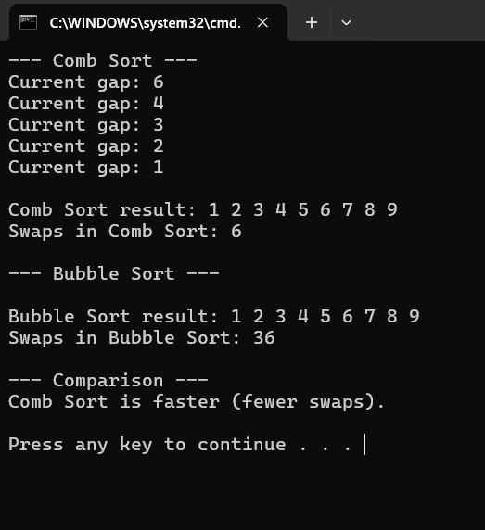
6.
#include <iostream>

using namespace std;

int binarySearch(const int arr[], int size, int target, int &comparisons) {
int left = 0;
int right = size - 1;
comparisons = 0;

while (left <= right) {
int mid = left + (right - left) / 2;
comparisons++;

if (arr[mid] == target) {
return mid;
} else if (arr[mid] < target) {
left = mid + 1;
} else {
right = mid - 1;
}
}

return -1;
}

int main() {
int rollNumbers[] = {101, 105, 110, 120, 135, 150};
int size = sizeof(rollNumbers) / sizeof(rollNumbers[0]);

int target;
cout << "Enter roll number to search: ";
cin >> target;

int comparisons = 0;
int result = binarySearch(rollNumbers, size, target, comparisons);

if (result != -1) {
cout << "Roll number found at index " << result << "." << endl;
} else {
cout << "Roll number not found." << endl;
}

cout << "Number of comparisons: " << comparisons << endl;

return 0;
}
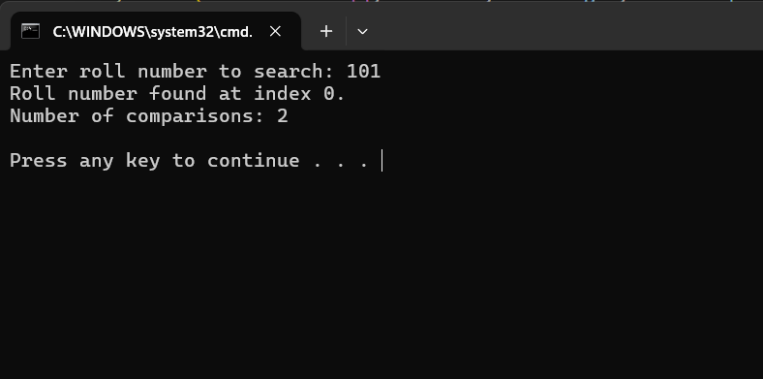
7.
#include <iostream>
using namespace std;

int interpolationSearch(int arr[], int size, int target, int &comparisons) {
int low = 0, high = size - 1;
comparisons = 0;

while (low <= high && target >= arr[low] && target <= arr[high]) {
comparisons++;
if (arr[high] == arr[low]) break;

int pos = low + ((target - arr[low]) * (high - low)) / (arr[high] - arr[low]);

if (pos < low || pos > high) break;

if (arr[pos] == target)
return pos;
else if (arr[pos] < target)
low = pos + 1;
else
high = pos - 1;
}

return -1;
}

int binarySearch(int arr[], int size, int target, int &comparisons) {
int left = 0, right = size - 1;
comparisons = 0;

while (left <= right) {
int mid = (left + right) / 2;
comparisons++;

if (arr[mid] == target)
return mid;
else if (arr[mid] < target)
left = mid + 1;
else
right = mid - 1;
}

return -1;
}

int main() {
int prices[] = {10, 20, 30, 40, 50, 60, 70, 80};
int size1 = sizeof(prices) / sizeof(prices[0]);

int priceToFind;
cout << "Enter product price to search: ";
cin >> priceToFind;

int interpComparisons = 0;
int pos = interpolationSearch(prices, size1, priceToFind, interpComparisons);

if (pos != -1)
cout << "Price found at position " << pos << endl;
else
cout << "Price not available" << endl;

cout << "\n--- Comparison: Searching for 45 ---" << endl;
int data[] = {5, 10, 15, 20, 25, 30, 35, 40, 45, 50};
int size2 = sizeof(data) / sizeof(data[0]);
int target = 45;

int binaryComparisons = 0, interpolationComparisons = 0;

int binIndex = binarySearch(data, size2, target, binaryComparisons);
int interpIndex = interpolationSearch(data, size2, target, interpolationComparisons);

cout << "Binary Search comparisons: " << binaryComparisons << endl;
cout << "Interpolation Search comparisons: " << interpolationComparisons << endl;

if (binaryComparisons < interpolationComparisons)
cout << "Binary Search is more efficient in this case." << endl;
else if (interpolationComparisons < binaryComparisons)
cout << "Interpolation Search is more efficient in this case." << endl;
else
cout << "Both searches performed equally well." << endl;

return 0;
}

